Mr SGs Atomic Structure & Periodic Table Notes

-Chemistry is the study of matter (anything that occupies space and has mass)

-All matter is comprised of atoms, but until recently, we have been unable to see atoms and we are still unable to directly observe the inside of atoms

-Different models of the atom have been proposed throughout history

-As new evidence has been discovered, atomic models have been updated to incorporate new discoveries

-Rather then thinking of models as being correct or incorrect, it is more useful to think about them in terms of how well they are able to explain our observations

Historical Models of the Atom

Leucippus and Democritus: 460-370 BC
Model | Matter is composed of indivisible particles called atoms
Evidence | This model was not based on experimental evidence

John Dalton: 1803-1808 (Billiard Ball Model)
Model | -Elements are composed of extremely small particles called atoms  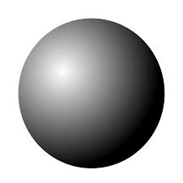  -All atoms of an element are identical in terms of size, mass and chemical properties  -Atoms are not created, destroyed or changed into another element during chemical reactions, but they can be separated, combined or rearranged  -Compounds are composed of atoms of different elements chemically combined in a fixed ratio
Evidence | -Research by Antoine-Laurent Lavoisier (1789) demonstrated mass is conserved in chemical reactions  -John Proust (1794) experimentally demonstrated that compounds contain elements combined in specific mass ratios  -Dalton demonstrated that the same elements can combine in different whole number ratios to produce different compounds

JJ. Thomson: 1904 (Plum Pudding Model)
Model | -Atoms consisted of small negatively charged electrons embedded in a positively charged sphere
Evidence | -Thomson discovered electrons through his research on cathode ray tubes  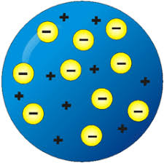  -When a large voltage is applied to a cathode ray tube (a partially evacuated glass tube), it produces a glowing cathode ray between the two terminals  -Thompson proposed the ray was composed of particles with mass  -Cathode rays can be bent towards a positively charged metal plate, demonstrating they are negatively charged  -Thomson was able to estimate the mass: charge ratio of electrons

Ernest Rutherford: 1911 (Planetary Model)
Model | -Atoms are mostly empty space, with electrons orbiting a small positively charged nucleus containing protons
Evidence | -Alpha particles (⁴He²⁺) were fired at a sheet of gold foil  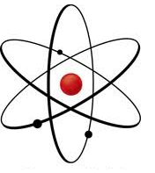  -The vast majority were able to pass through, indicating the atoms were mostly empty space  -A small fraction were significantly deflected, indicating the presence of small regions of highly concentrated positive charge (e.g. nuclei)

Neils Bohr: 1913 (Bohr’s Quantum Model)
Model | -Electrons orbit the central nucleus (as per the planetary model)  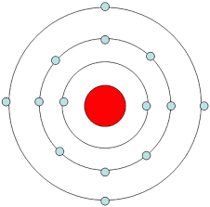  -Only certain orbital radii are permitted, each containing electrons possessing a certain amount of energy  -The amount (quanta) of energy increases for orbits further from the nucleus  -Electrons can absorb energy (as photons/heat/electricity) to move to a higher orbit or emit energy (as a photon) to move to a lower orbit
Evidence | -Under Rutherford’s model, orbiting electrons should lose energy as radiation and spiral into the nucleus  -Bohr’s model also explained the phenomenon of emission and absorption spectra

Erwin Schrödinger/Werner Heisenberg: 1925-6 (Quantum Mechanical Model)
Model | -Electrons have a wave and a particle nature  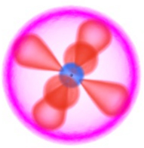  -The wave nature explains the different energy states of electrons  -Rather than circular orbits, electrons move within regions called orbitals, which exist within defined energy levels  -Each energy level contains n² orbitals (where n is the number of the energy level), each containing 2 electrons  -While the exact location of an electron cannot be specified, an orbital corresponds to a probability distribution of where the electron is likely to be found
Evidence | -Louis de Broglie proposed all particles could be treated as matter waves (1924)  -Werner Heisenberg proposed the uncertainty principle whereby it is impossible to determine both the energy and position of an electron, and developed an early quantum mechanical model (1925)  -Schrödinger formulated an equation that allowed electrons in orbitals to be treated as matter waves, allowing the probability of finding an electron in a given location to be calculated (1926)

James Chadwick: 1932 (Neutrons)
Model | -As per the quantum mechanical model, but with the nucleus containing positively charged protons and uncharged neutrons  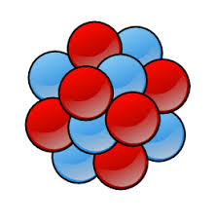
Evidence | -Research by Hans Geiger and Ernest Marsden demonstrated that protons only accounted for around half the nucleus’ mass  -James Chadwick bombarded Beryllium with alpha particles and identified neutrons as an uncharged product

Atomic Structure

-In high school Chemistry, we use a modified Bohr model of the atom

-This model is simpler than the latest quantum mechanical models, but is able to explain all of the properties of atoms that we need to model

Subatomic Particles

-Atoms consist of three subatomic particles; protons, neutrons and electrons

-The protons and the neutrons form the nucleus and the electrons are located in the electron cloud (arranged in distinct energy levels)

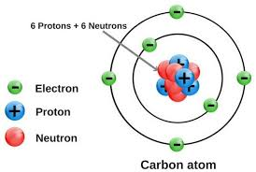

Particle | Proton | Neutron | Electron
Charge | +1 | 0 | -1
Mass | 1 | 1 | 1/2000

-Protons have a + charge and electrons have a – charge. The attraction between these particles is what prevents the electrons from escaping the atom

-Neutrons do not have a charge.

-Protons and neutrons are approximately equal in mass, but electrons have a far smaller mass

Ions

-Ions are charged atoms that have lost or gained electrons to become + or - charged
charge = Z – (# of e⁻)

-Positive ions are called cations and negative ions are called anions

-The charge of an ion is shown as a superscript to the right of the ion e.g. Na⁺ Mg²⁺ F⁻ O²⁻

Atomic number and mass number

-An atoms identity is defined by the number of protons in its nucleus eg Carbon always has 6 protons, lithium always has 3 protons

-This number is referred to as the Atomic number (Z)

-A substance that contains only one type of atom is called an element

-Atoms of an element always have the same number of protons, but they can have different numbers of neutrons

-Atoms of an element that have a different number of neutrons are called isotopes

-Isotopes are identified by their Mass number (A) e.g. Carbon-12, Nitrogen-14

- Mass number (A) is the number of protons + the number of neutrons e.g. Carbon-12 has a mass number of 12 (6 protons + 6 electrons)

-In Chemistry, there are approximately 90 naturally occurring elements that are given symbols that are used as shorthand (e.g Hydrogen = H, Iron = Fe)
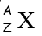
-An atoms symbol is often listed with its atomic number and mass number in the format:

Relative Atomic Mass

-Relative Atomic Mass (A_{r}) is closely related to mass number (A)

- A_{r} = mass relative to 1/12 the mass of a C-12 atom (~ mass relative to a proton or a neutron)

- A_{r} = A (for samples containing only one isotope)

-The A_{r} values in the periodic table are a weighted average for the isotopes of that element

- A_{r} of element = ∑ (% abundance of each isotope x A_{r} of isotope)
100

-A neutral atom has the same number of protons and electrons (e.g. # of e⁻ = Z)
Mass Spectrometry

-The relative atomic mass of an element can be determined using a mass spectrometer

-They can also be used to determine the relative molecular mass of a compound

-Mass spectrometers calculate an elements A_{r} by measuring the mass to charge (m/z) ratio of gaseous atoms of an element

-They are able to detect the mixture of isotopes present in a sample of an element.

-Many variations of mass spectrometer exist, but they all use the following steps:

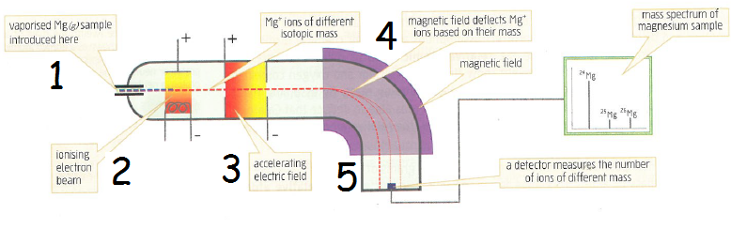

1) Vaporisation: The sample to be analysed is vaporised in a vacuum chamber. Atoms must be in the gaseous state for mass spectroscopy to work

2) Ionisation: The gaseous atoms are bombarded with an electron beam, removing electrons from the atoms. This forms +1 (and a small number of +2) ions of the element

3) Acceleration: The resulting ions are accelerated into a high-speed beam by an electric field (a positive and negatively charged plate)

4) Deflection: Ions pass through a strong magnetic field that deflects them in a circular path based on their m/z ratio. Ions with a lower mass are deflected more than ions with a larger mass

5) Detection: A detector measures the relative intensity (e.g. abundance) of each isotope. The m/z ratio (equal to A_{r} for +1 ions) is displayed on the x -axis and the % Abundance is displayed on the y-axis
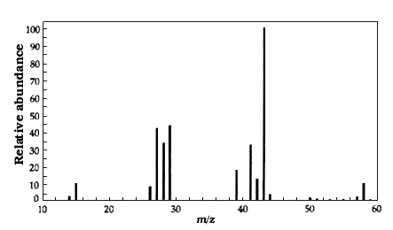
Electron Configuration
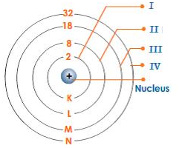

-The electrons in an atom exist in energy levels or shells surrounding the nucleus

-The shells are denoted by numbers (1,2,3,4) or letters (K,L,M,N)

-Each shell can hold 2n² electrons, where n= shell number

-Electrons tend to be in shells with the lowest energy levels

-We can calculate the electron configuration of an atom or ion by following this procedure:

-The first 2 electrons are assigned to shell 1
-The next 8 electrons (3-10) are assigned to shell 2
-The next 8 electrons (11-18) are assigned to shell 3
-The next 2 electrons (19-20) are assigned to shell 4
-The next 10 electrons (21-30) are assigned to shell 3

-The reason that electrons 19-20 are assigned to shell four is that each shell is actually comprised of a number of subshells (designated s, p, d and f) that have different energy levels. The 4s subshell (which can hold 2 electrons) has a lower energy than the 3d subshell

-The electron configuration is written by showing the number of electrons in each shell written in brackets, separated by commas e.g. Sodium: (2,8,1)

*Note: spdf suborbitals are no longer include in the Year 11 course. The current syllabus only requires you to assign electrons for up to 20 electrons (2,8,8,2)*
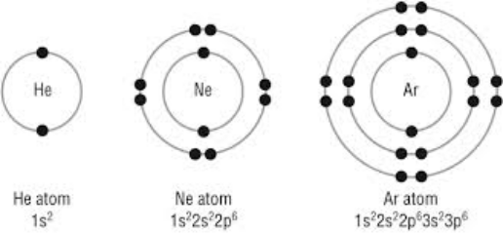
-Electron configuration can also be represented graphically by showing the electrons in shells. After the first shell, the electrons are drawn in pairs

Valence Electrons
-The electrons in the outermost shell are referred to as valence electrons. These determine many of the properties of substances.

-It is very unstable for atoms to have partially filled electron shells. Atoms will tend to delocalise, donate, accept or share electrons to acquire a full valence shell.

Electron Structure and the Periodic Table
-As well as using the 2,8,8,2 rule, an elements electron configuration can be calculated using the periodic table

-The periodic table is arranged so that all elements in a period (row) have their valence electrons in the same shell. An elements period number tells you the number of occupied electron shells that element has.

Example: Calcium is in period four, therefore it has three completely filled electron shells, with its valence electrons located in the partially filled fourth shell

-All elements in a group (column) have the same number of valence electrons. For elements in Groups 1 and 2, the group number is equal to the number of valence electrons. For elements in Groups 13-18, the number of valence electrons is 10 less than the group number

Example: Aluminium is located in group 13, therefore it has three valence electrons.

Example: Sodium is in Period 3 (eg it has electrons in 3 shells), Group 1 (eg it has 1 valence electron), so it’s electron configuration will be 2,8,1

-The periodic table also shows which sub-orbital an element’s valence electrons are located in *not in Yr 11 syllabus*

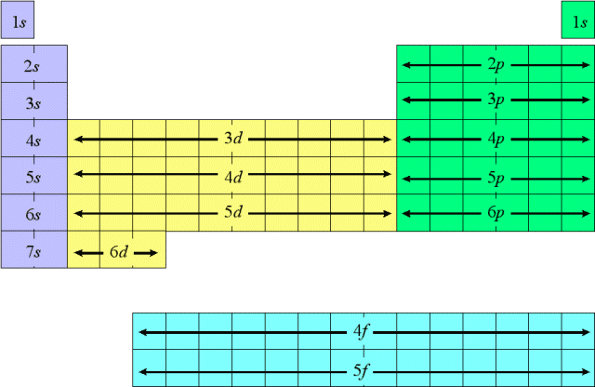

Periodic Table Structure

-The periodic table lists all elements in order of increasing atomic number

-The elements are organised into groups (columns) and periods (rows), so that elements with similar properties are grouped together
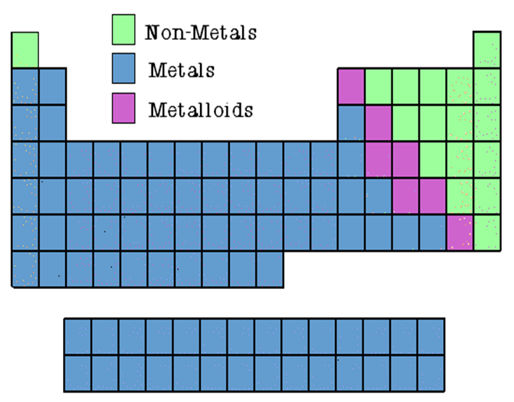

-Metals are on the left of the periodic table, with non-metals on the right

-The elements near the line separating them are sometimes referred to as semi-metals or metalloids

Groups
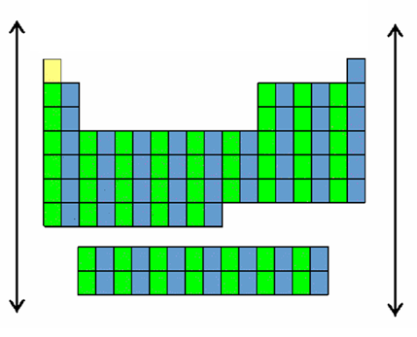
-Periodic table groups are numbered 1-18 from left to right

-Elements within a group have the same number of valence electrons

-Group 1 & 2 elements have 1 & 2 valence electrons, while Group 13-18 elements have 3-8 valence electrons

-Elements within a group have similar chemical properties as these properties are largely determined by the valence electrons

Periods
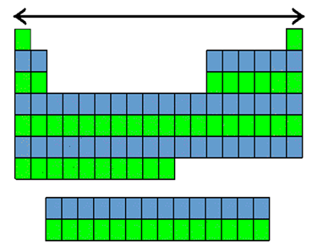
-Periods are numbered 1-7 from top to bottom

-An elements period number corresponds to the number of occupied energy levels/shells it possesses (eg all elements in Period 3 have completely filled shells 1 & 2, with their valence electrons in the third shell)

-Elements within a period do not have similar chemical properties

Important Groups of Elements
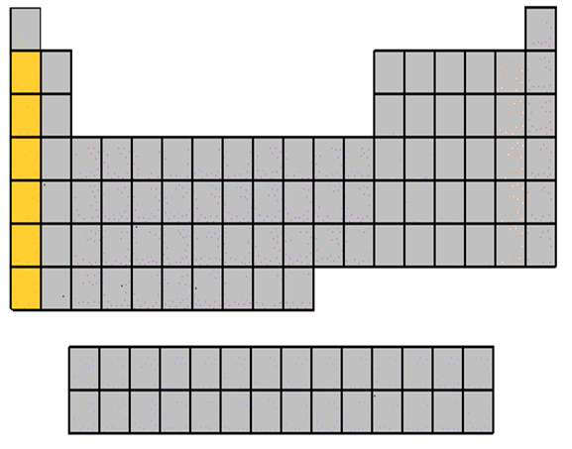
Alkali metals (Group 1)
-Highly reactive metals that react with water to produce hydrogen gas
-Relatively soft, with low MP for metals

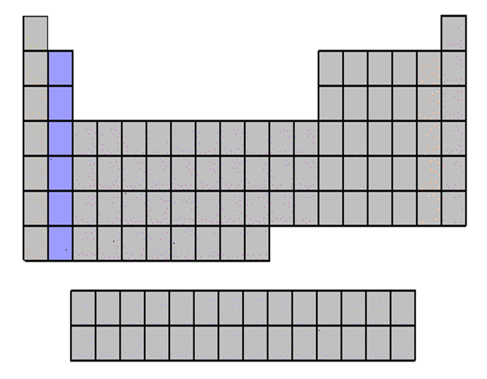
Alkaline Earth Metals (Group 2)
-Reactive metals that form basic oxides

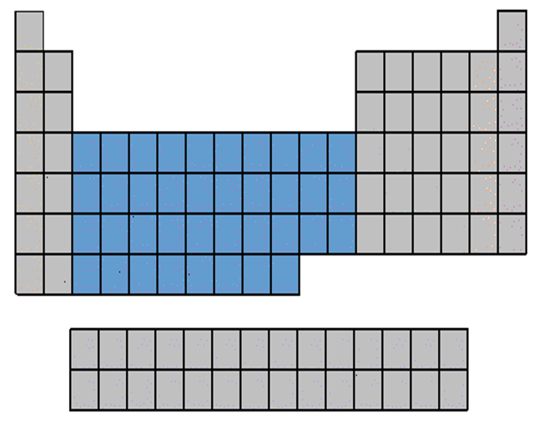
Transition Metals (Groups 3-12)
-Denser metals with higher MP than Group 1 & 2 metals
-Often form coloured ions

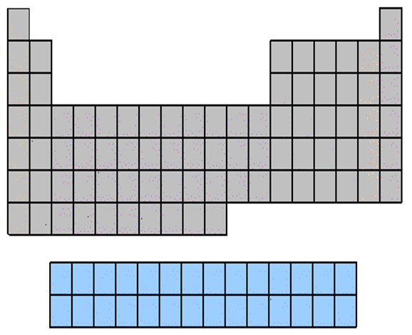
Lanthanides and Actinides
-Metals with high molecular weight
-Contain several radioactive elements
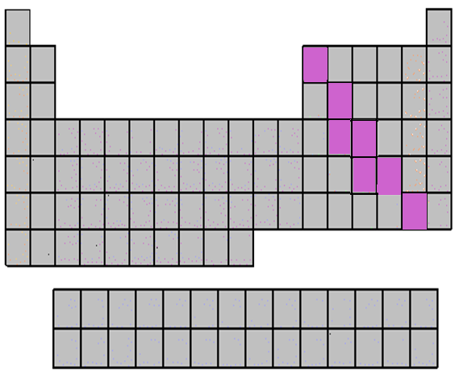
Metalloids
-Elements with a mixture of metallic and non-metallic properties

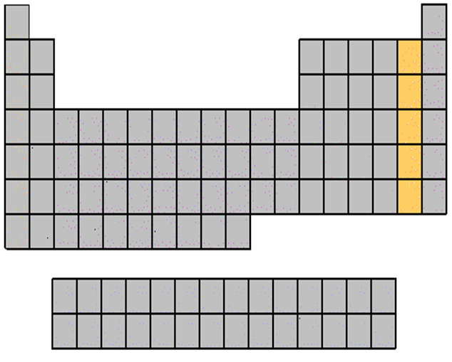
Halogens (Group 17)
-Highly reactive non-metals
-Exist as diatomic molecules in their elemental forms

Noble Gases (Group 18)
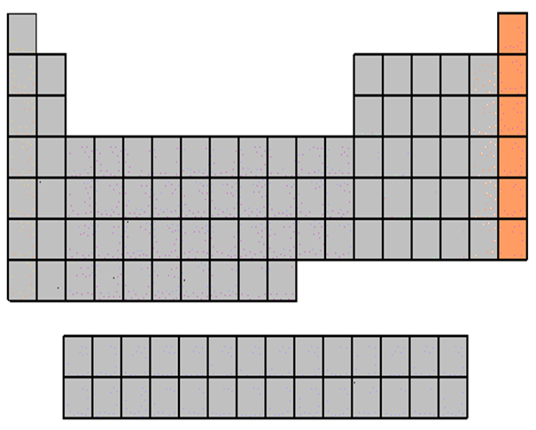
-Unreactive non-metals
-Exist as monoatomic molecules
Periodic Table Trends

-Many of the physical and chemical properties of elements display clear trends moving across periods and down groups in the periodic table

-Most of these trends can be explained by changes in effective nuclear charge (also called core charge) and atomic radius

Effective nuclear charge (Z_{eff})
-Effective nuclear charge is a measure of the pull the nucleus of an atom is able to exert on valence electrons

-While positively charged protons attract valence electrons, this attraction is partially shielded by non-valence electrons which exert a repulsive force on the valence electrons

-These non-valence electrons are called shielding electrons

Z_{eff} = Z - # of shielding electrons

-For example, Calcium has 20 protons and 18 shielding electrons, so it has a Z_{eff} of 2

-For neutral atoms, effective nuclear charge is equal to the number of valence electrons

Atomic Radius
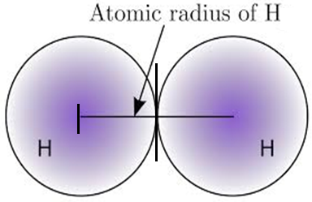
-Atomic radius is defined as the distance between the centre of an atom’s nucleus and its outermost electron shell

-It can also be defined as half the distance between two adjacent atoms in a metallic lattice or a diatomic molecule

-Atomic radius decreases moving left to right across a period, as additional electrons are being added to the same shell, but Z_{eff} is increasing, pulling valence electrons closer to the nucleus

-Atomic radius increases moving down a group, as Z_{eff} remains constant, but new electron shells are being added which are further from the nucleus

First Ionisation Energy
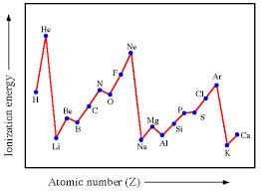
-First Ionisation Energy is the energy required to remove one mole of electrons from one mole of atoms in the gaseous state (measured in kJmol⁻¹)

-First Ionisation Energy increases moving left to right across a period as the increasing Z_{eff} and decreasing atomic radius mean the nucleus is exerting a greater pull on the valence electrons

-First Ionisation Energy decreases moving down a group as the decreasing Z_{eff} and increasing atomic radius mean the nucleus is exerting a lesser pull on the valence electrons

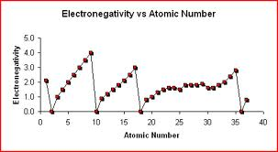
Electronegativity
-Electronegativity is a measure of an atoms ability to attract a pair of bonding electrons

-Electronegativity increases moving left to right across a period as the increasing Z_{eff} and decreasing atomic radius means that the bonding electrons are being attracted by a larger force acting over a shorter distance

-Electronegativity decreases moving down a group as the increasing atomic radius means that the bonding electrons are further from the nucleus

Other Periodic Trends
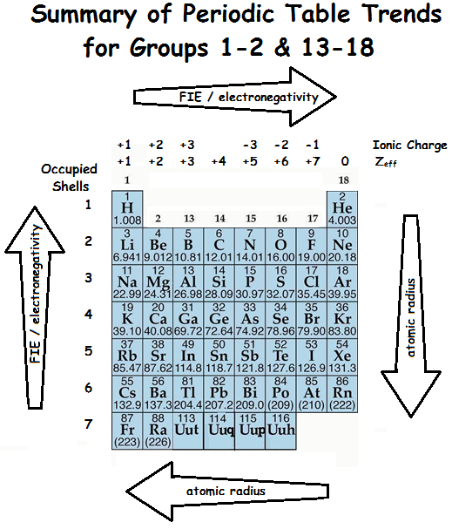
-Electron affinity (ability of a gaseous atom to accept an electron) increases moving to the top right of the table (same reasons as electronegativity)

-Metal reactivity increases moving down a group due to decreasing FIE

-Non-metal reactivity decreases moving down a group due to decreasing electronegativity/ electron affinity
Excitation and Emission

-The electrons in an atom exist in energy levels or shells surrounding the nucleus

-Electrons can absorb a definite amount of energy (in the form of heat, electricity or a photon) and become excited (this is when an electron jumps from its ground state to another energy level).
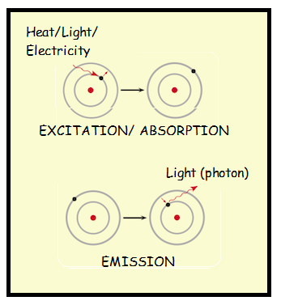

-Excited atoms are unstable and the electrons quickly move back to lower energy levels

-When an electron jumps from a higher level to a lower level, a photon is emitted.

-The energy of the photon is equal to the difference in energy between the two orbitals.

-As the frequency of a photon is proportional to the energy of the photon, photons of different energies (corresponding to different orbital transitions) will be different colours (if their frequency is part of the visible spectrum)

-As different atoms have different electron configurations, they will absorb and emit different specific frequencies of light.

Flame tests
-Many ionic solids will emit specific colours of light when they are placed on a metal loop and held in a Bunsen burner flame

-The colour of the flame depends on the metal ion (cation) present
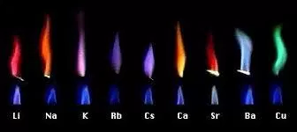
-Electrons in the cation absorb heat energy to become excited, then emit specific wavelengths (colours) of light when they return to their ground state

-Flame tests are a qualitative method for determining the cation in a salt

-Some cations produce colours that are difficult to distinguish

Emission and Absorption Spectra

-If the light emitted by an element is passed through a prism (or a spectroscope), it can be split into a spectrum showing the wavelengths of light emitted by an element

-As each element has a unique electron configuration, they all emit different wavelengths of light

-As such, it is possible to identify elements by their emission spectra (see below)

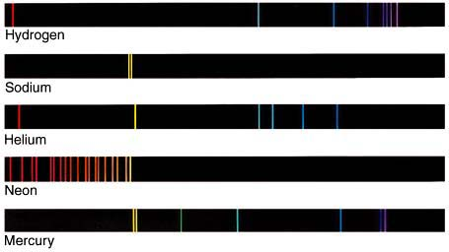

-Elements can also absorb light to become excited, by absorbing photons whose energy corresponds to the difference between two of their energy levels

-As such, elements can also be identified by the wavelengths of light they can absorb (absorption spectra)

-In an absorption spectrum, the wavelengths of light that are absorbed can be observed as “missing” black lines (see below)



Atomic Absorption Spectroscopy (AAS)

-AAS is a quantitative method for determining the concentration of an element in a mixture/sample

-It works on the principle that gaseous atoms of an element are only able to absorb specific wavelengths of light (e.g. the black lines on their absorption spectrum) and that the amount of light absorbed is proportional to the concentration of the element

-AAS Works as follows:

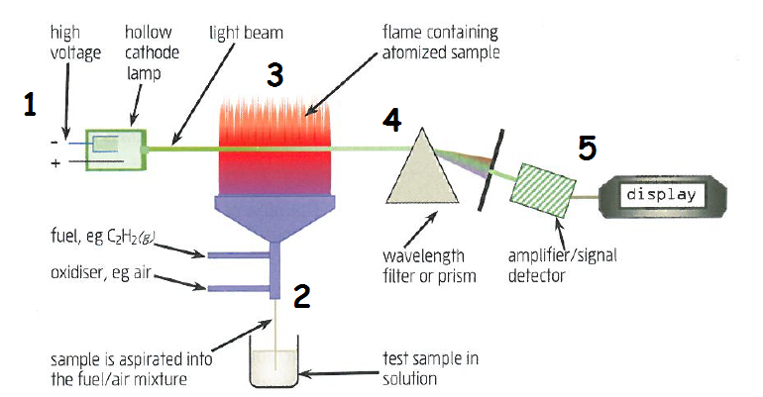

1) Light of the correct wavelength is generated using a hollow cathode lamp made using the element that is being detected (so the correct wavelengths are generated)

2) The sample being tested is sucked into the fuel/air mixture, producing a flame containing the now atomised sample

3) Light from the lamp passes through the flame and is partially absorbed by the atomised sample. The greater the concentration of the sample, the more light is absorbed

4) A wavelength filter or prism is used to split the light, so that the appropriate wavelength can be analysed

5) A detector measures the absorbance (the amount of light that has been absorbed)

Calibration Curves
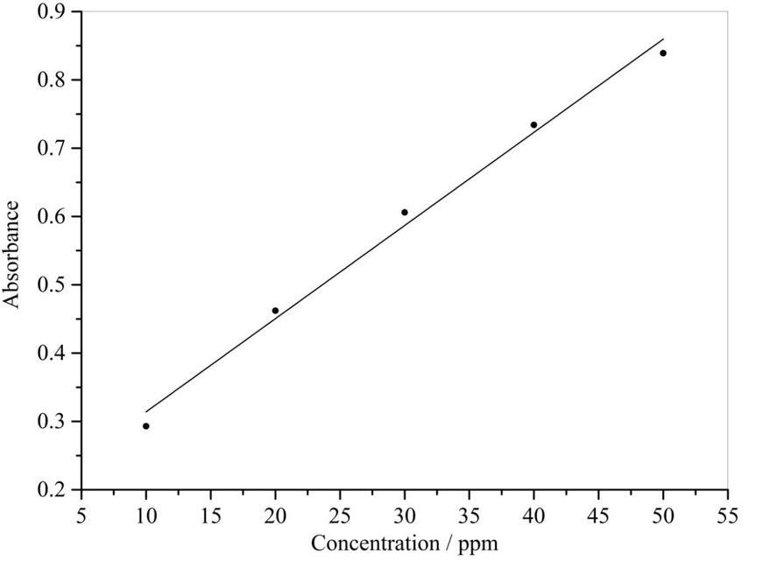
-The absorbance data needs to be compared to a calibration curve to determine the concentration of the sample

-To prepare a calibration curve, standard solutions (samples with known concentrations) are prepared and their absorbances measured

-A graph is prepared, plotting the concentration of each standard to its absorbance

-The concentration of the unknown can then be determined by using the calibration curve to check the concentration that corresponds to the measured absorbance

